**RIMT University Canteen Mobile Application**

* + - The main aim of this project RIMT University Canteen Mobile Application is to provide fast services to their college students, Staffs etc. Usually People have to go to the canteen and order the food and they have to wait in the queue for a long time to get the orders. But with the help of this you just have to follow a very simple process to order your stuff. And you need not to wait in the long queue
    - This Application will provide a list of different menu lists with different categories. Users can select any item from the canteen and can order for it by using debit card payment or wallet Payment. Wallet Recharging available with debit card details or admin can add an amount in the user's wallet.
    - Users have to register with valid details and OTP which will get sent to their mobile number to login with the canteen. Users also get recommendations for food items, Trending food items.
    - The Canteen Management system manages all details of food items which contain name, description, image, price etc. Admin can view the confirmed order and update the status of the order accordingly.
    - Customers can check their balance, order history and are able to delete the order according to order status.
    - This system also prominently relieves the burden on the canteen’s end, as the entire method of taking orders is computerized. Once an order is placed on the android phone, it is entered into the database and then retrieved, in pretty much real-time, by a desktop application on the canteen’s end. Within this application, all items in the order are displayed, along with their equivalent options and supply details, in a summarizing and easy to read manner.
    - This allows canteen staff to speedily go through the orders placed by scanning the QR code from the student's phone and produce the needed items with minimal delay and confusion.

## Advantages

* + - * Completely automated online ordering of food in a canteen.
      * Orders can be placed using personal android phones.
      * Food ordering pages that look and feel exactly the same as the existing restaurant website.
      * Food ordering pages hosted on secure and special servers so no risk of customers getting redirected to servers where competitors’ websites are listed.
      * Developed using the latest website programming protocols for minimum server loads and ultra-fast loading and processing.

## : Modules Of the Project

RIMT University Canteen Mobile Application allows you to access and purchase food items from your RIMT University Canteens with a convenient app. You Create an account and pay for purchases at participating University Canteen at RIMT University. It comprises all the listed offline canteen of the University on a single mobile application designed to skip all the queue you stand in and waste your time. All the items that are present on the canteen app are available to through the user of the RIMT University Canteen Mobile Application.

* + 1. **: Screens:**

Splash Screen**:** The very first screen the user will see when the app will start up, the duration of the splash screen is 3 seconds.

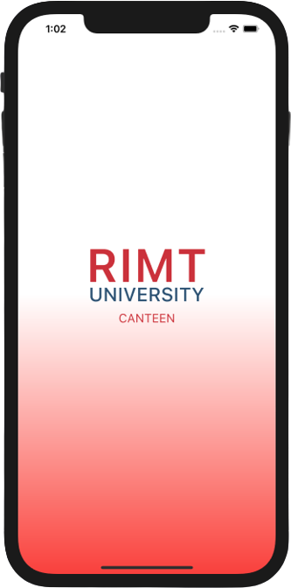

Fig 1.7: Splash Screen

Introduction Screen: After landing on the Introduction page the user will see 2 buttons.

i: Student Button

ii: Canteen Owner Buttons

By clicking each button the user will land to the respected portal for their own preferences, the student will land on the student portal and the canteen owner will land on the administrator’s portal.

Sign In Screen: the user can create and sign in using their email address and access the RIMT University Canteen Mobile Application. The sign in screen contains:

* An email field
* A password field
* A sign-in button

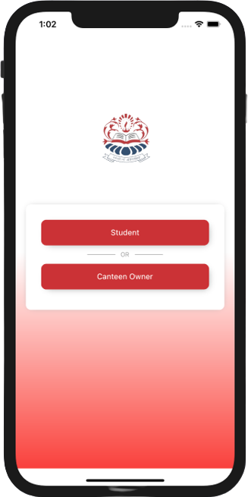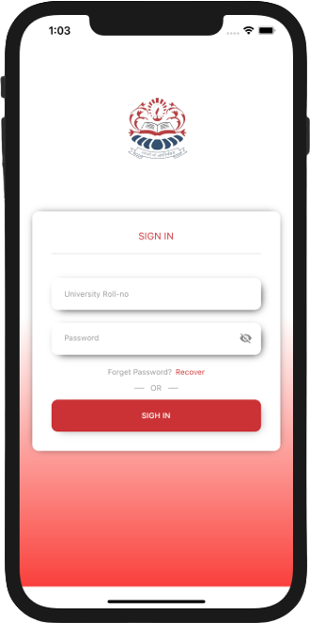

Fig 1.8: Introduction Screen Fig 1.9: Sign In Screen

Home Screen: After successfully sign in the user now will be able to see the home interface where the user can see the profile section in the upper part of UI and can see the favorite food in Favorite food section, can see order history in the Order Book section and the user can go through the current order by clicking Your Order.

Listed Canteens:

* IET Canteen
* Samosa Express
* Kashmiri Canteen
* PK Canteen
* Nescafe
* Amul
* Cafe Luscious
* Bharosa Food

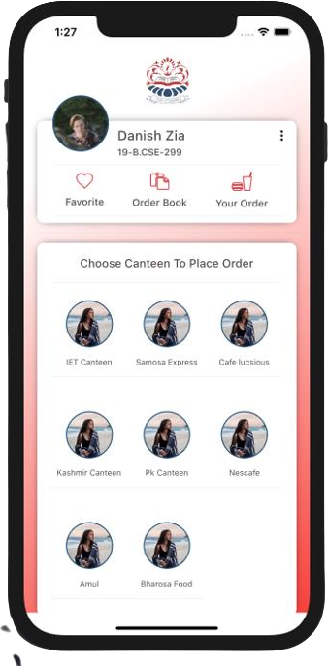

Fig 1.10: Home Screen

Menu Card Screen: the user can press on any of the Icon of the canteen from which the user wants to order the food, just by pressing the icon the user will be navigated to the menu screen of the canteen the user wants. On the menu screen the user can see the “Menu Card” written on the top of the screen, just beneath that the user can use the search bar to search the food. The user’s choice also allows the user to directly access the Tab Bar for Vegetarian food, Non-Vegetarian food and Beverage.

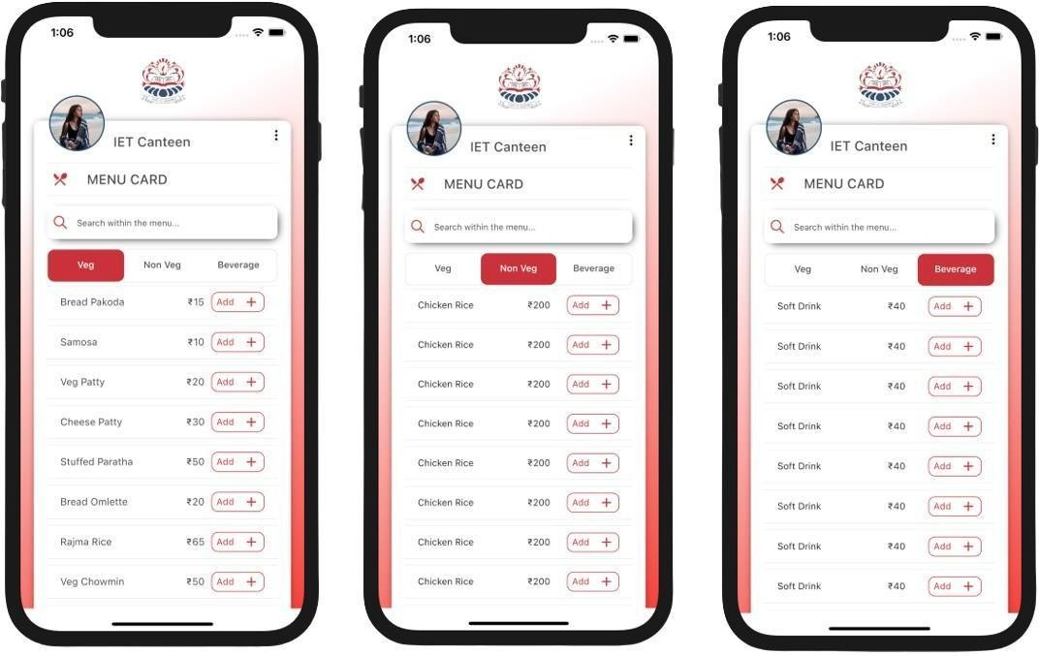

Fig 1.11: Vegetarian food Fig 1.12: Non-Vegetarian food. Fig 1.13:Beverage

Your Bag Screen: When the user is done selecting the food from the Menu Card Screen. the user will be directed to the Order Bag Screen by pressing the CheckOut button on the Menu Card Screen. On the Order Bag Screen The User will be able to see the selected food the user wants to order from the selected canteen. The user can click the Proceed To Pay button and will reach the next Screen.

Flutter is an open-source framework by Google for building beautiful, natively compiled, multi-platform applications from a single codebase. Flutter transforms the application development process. Build, test, and deploy beautiful mobile, web, desktop, and embedded apps from a single codebase.

Your Bag Screen: When the user is done selecting the food from the Menu Card Screen. the user will be directed to the Order Bag Screen by pressing the CheckOut button on the Menu Card Screen. On the Order Bag Screen The User will be able to see the selected food the user wants to order from the selected canteen. The user can click the Proceed To Pay button and will reach the next Screen.

Payment Screen: After the clicking Proceed To Pay button the user of the Application can will be navigated to the Payment Screen, where the user can pay through multiple payment option such as Debit/ Credit Card, UPI(Google Pay and Paytm), the user can also choose cash to pay.

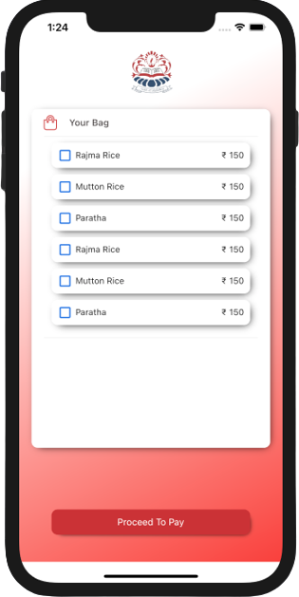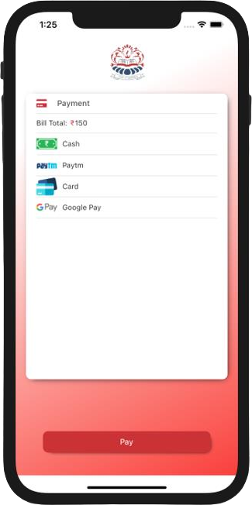

Fig 1.14: Order Bag Screen Fig 1.15: Payment Screen